Họ và Tên: Trần Anh Dũng
Lớp: E22CNPM01
MSV: B22DCDT059
Question 1:

- UC diagram module Reader find document information
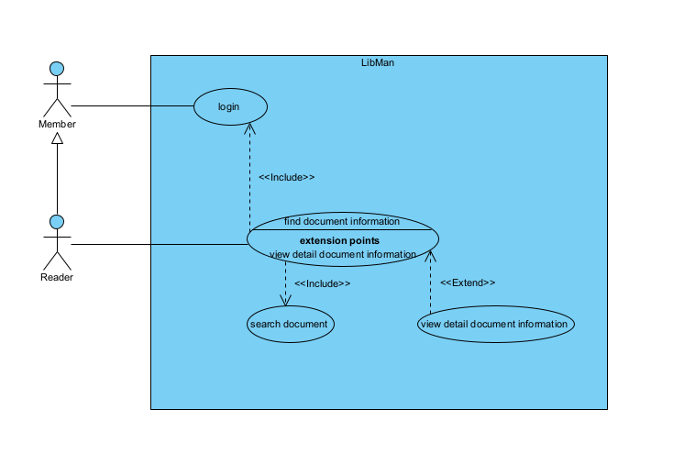
- UC diagram module Library staff lends document to reader
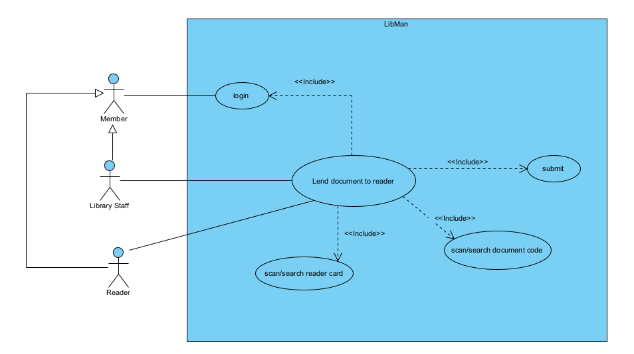
- UC diagram Register reader card
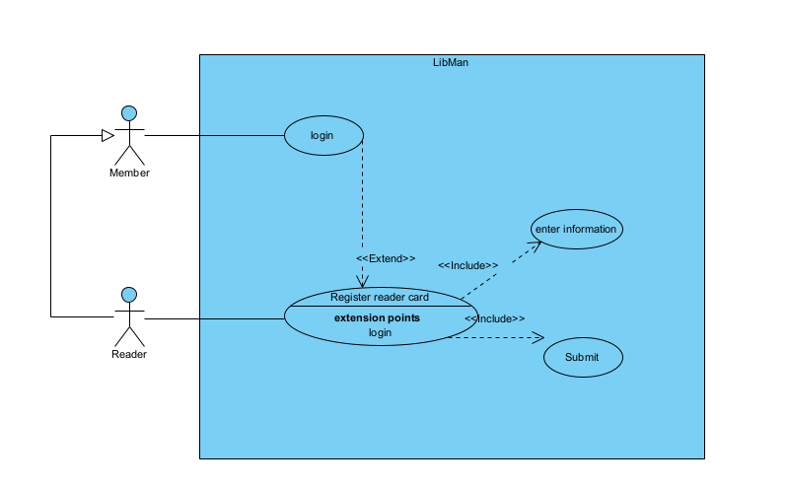
- UC diagram Return document
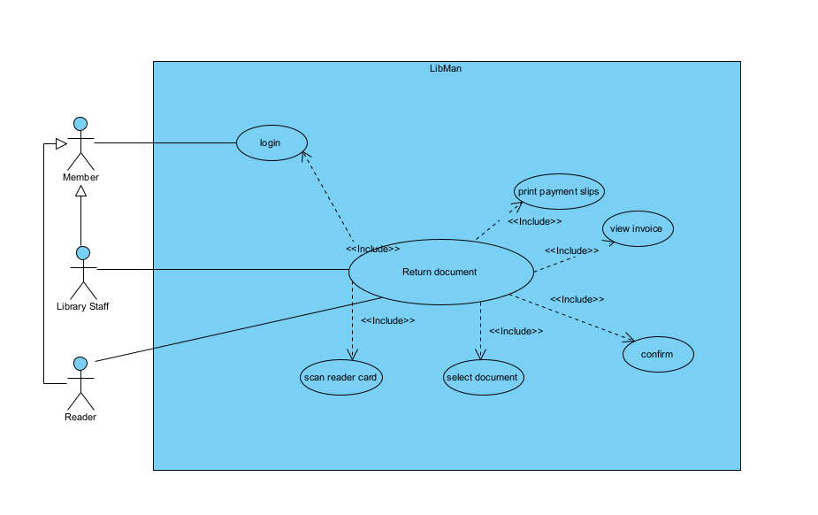
- UC diagram Import document from suppliers
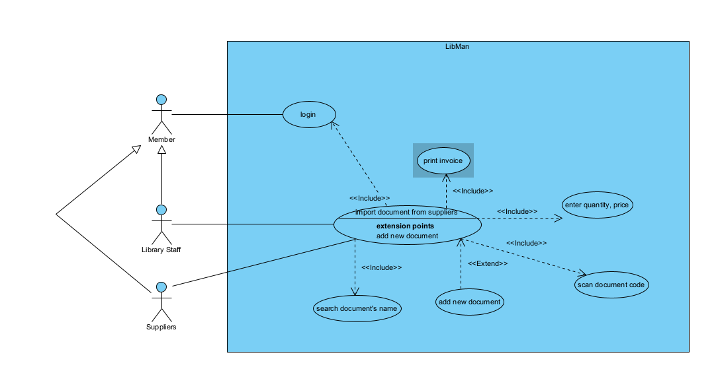
- UC diagram View document statistics
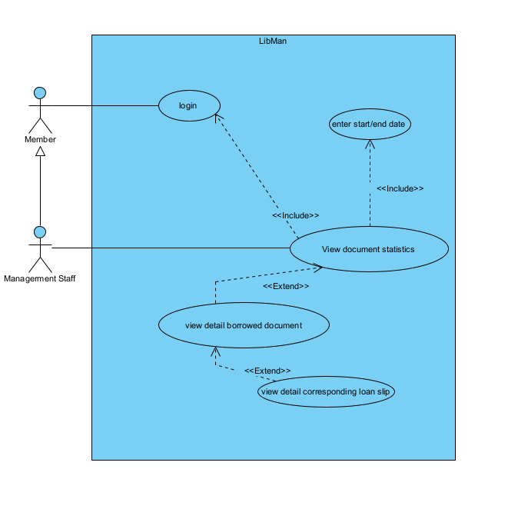
- UC diagram View reader statistics
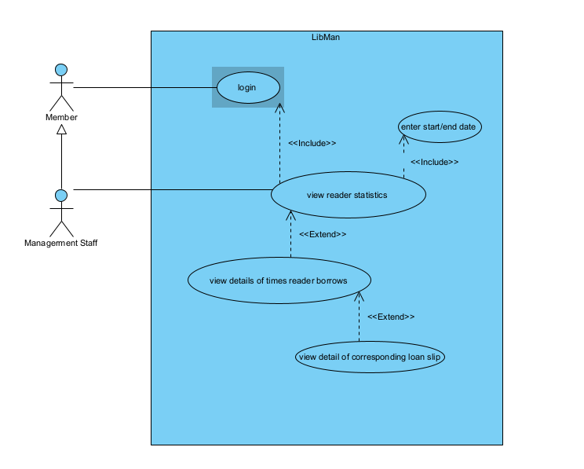
- UC diagram View supplier statistics
Tương tự 2 cái thống kê kia
- Viết Scenario
Module 1
Scenario | Reader find document information
Actor | Reader
Pre-Condition | Reader has an account
Post-Condition | Reader view document information
Main Event
Exception

Question 2:
- Extract
- Member: username, password, role, fullName
- Reader: age, gender, phone, cardCode
- LibraryStaff
- ManagermentStaff
- Supplier: address, phone
- Document: name, code, type, price, description
- DocumentStat: totalLend
- LoanSlip: loanDate, expectReturnDate
- ReturnSlip: returnDate
- PenaltySlip: penaltyPrice
- LoanDocument: status
- ImportInvoice: importDate, quantity, totalPrice, note
- Entity diagram
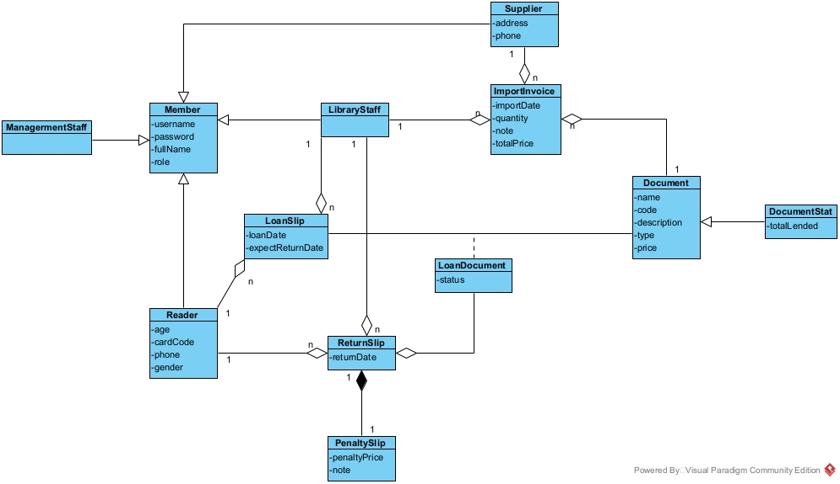

Question 4
